**GOVERNMENT DEGREE COLLEGE-RAJAMPETA,ANNAMAYYA Dt**

**::FACULTY PROFILE::**

**1,Name of the Employee : V. Malathi**

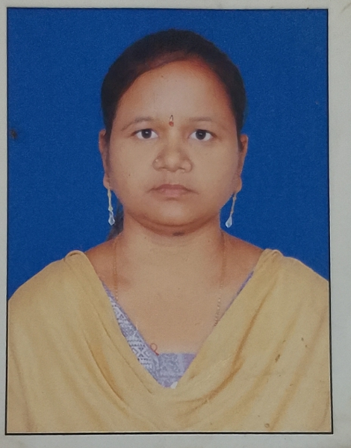

**2. Subject : Economics**

**3. Qualification : M.A.**

**4. Experiance : 17 Years**

**5. Books Published : Nil**

**6. No.of Journals Published : Nil**

**7. No.Of Scoping Indexed : Nil**

**8. Citation Index : Nil**

**9. Teaching paper Name : Economics**

**10. YouTube links : Nil**

**11. Blog Links : Nil**

**12. Awards if any : Nil**

**13. Mobile Number : 8142514242**

**14. E-Mail ID : sanjeevaprasadk@gmail.com**

**15. If any other information : Nil**

